**Modern Programming Languages**

Assignment No. 5

**Rules**

1. Deadline: 07 November 2024
2. Only hand-written assignment is acceptable
3. Copy-paste not allowed
4. ChatGPT and other online tools are not allowed to finish the assignment

**Question No. 1**

Create a Java Notepad application

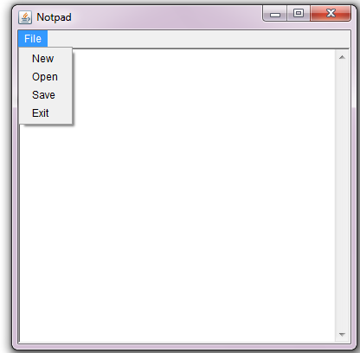

**Add the following functionalities**

1. **Whne you press the New** MenuItem, then it the TextArea is null then a new file is created and if there is some text in the TextArea then first ask the user “Do you want to save the file?” and execute the action as per needed.
2. **When user press the Open** MenuItem, then show the openfile dialg box and allow user to select a file and then display the file contents to this TextArea
3. **When a user press the Save** Menu item, then file should be saved with the name provided by the user.

**To see how a notepad works, you are required to** open the Window Notepad and observe how different options works there.

**Question No. 2 Design and code in Java the following**

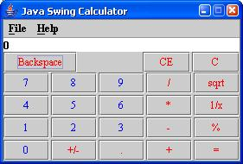

1. A four-function calculator with the following functions:  
* Addition – adds two numbers: n1 + n2.  
* Subtraction – subtracts number two from number one: n1 – n2.  
* Multiplication – Multiplies two numbers: n1 * n2.  
* Division – divides number two into number one: n1 / n2.

2. Used JButton for the numbers and functions.

3. Used Jmenu for File and help.  
4. Created a class to respond to the events caused by numbers, functions, exit, help and about functionality.